50 Years at Foothills Gateway: A Personal Perspective

Lee Anne Miller is a Foothills Gateway staff person who has been a part of the Foothills Gateway family for almost 30 years. Lee Anne shares with us some of her memories of various Foothills Gateway staff, as well as experiences that have shaped her professional growth and have been especially meaningful to her.

When did you first come to Foothills Gateway and what do you remember?
Around 1995, I lived with a foster mom and I knew Mary Ellen, a woman with disabilities who went to Foothills Gateway, and she asked me to come with her to FGI so I could be her aide. I agreed because I had been working at Wendy’s in 1994 and I didn’t like that job and thought this would be better. People weren’t always nice to me at Wendy’s. I asked Mary Ellen if people were nice here and she said yes, so I went for it.
After I started working as an aide, I sometimes came to work sad and crying because I had a hard time with my biological family on holidays when I saw them. Jackie O. would ask me what was wrong and try to support me. I loved working as an aide – helping with lunch and activities – and Jackie was a good boss.

After working as an aide in the Basesite and Retirement day program areas, what other jobs did you have?
I worked on the cleaning crew with Diane Bocanegra as my boss. We went out and cleaned houses. It was a good job and I liked working for Diane, but I decided I wanted a job in the community. Kathy Pidcock was a job coach who helped me find a job at Clearer Image eye center, but that eventually closed. Then she helped me find a job at a photo center that also closed. Another job coach, Jim Cox, helped me find a part time job at My Sister Knits. I love crafts and knitting so that was great. But I wanted more hours and we found a job for me at the Hallmark store on Harmony. I worked there 13 years before it was sold and the new owners didn’t want handicapped people there anymore. I had so many friends with my coworkers and customers; it was really hard to lose that job.
In 2019 I had open heart surgery. Since I couldn’t go back to Hallmark, I came back to work at Foothills Gateway on the cleaning crew. Lots of things changed during the pandemic and when we started bringing cleaning staff back to the building, they offered me a job as an employee at FGI as a member of the janitorial staff. I really like my job now. I like scrubbing everything down so people don’t get sick.

What has your experience been like at Foothills Gateway for the past 27 years? What changes have you seen?
I love it here. A change I see in day program is that we don’t hire aides anymore! Also, the cleaning crew is gone and there have been a lot of changes in the day program areas, VSTA and Production. I have seen things get better over the years. More people have jobs. I have had a lot of Case Managers that listened to me and helped me get what I need. Laura Sidener was my Case Manager a long time ago. We got along very well and she got me through some hard times. Now we are coworkers!
My happiest time at Foothills Gateway is now. I love being a part of the team, especially being back after Covid, supporting others, and getting paid to help other people.

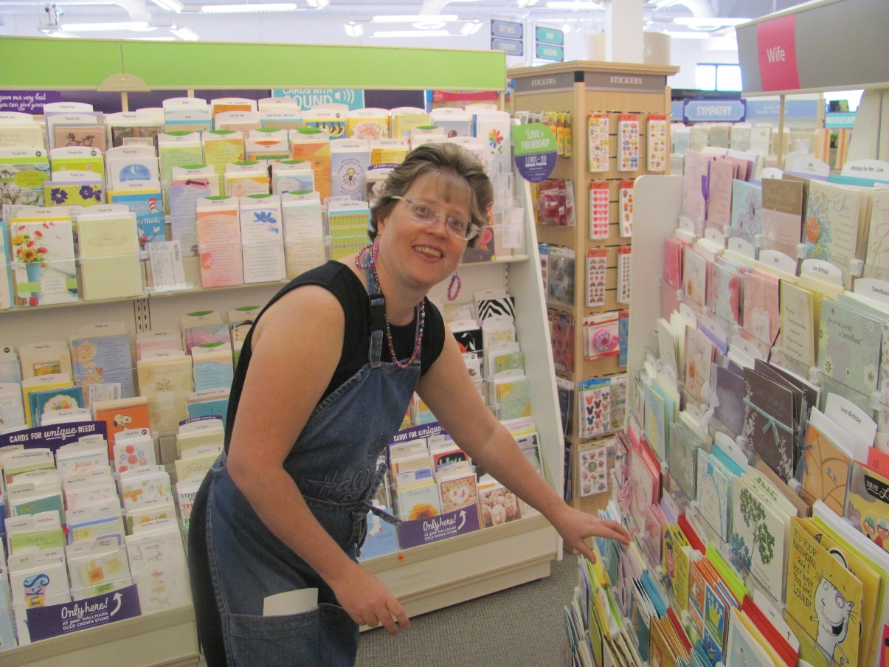
Lee Anne working at Hallmark in 2013

