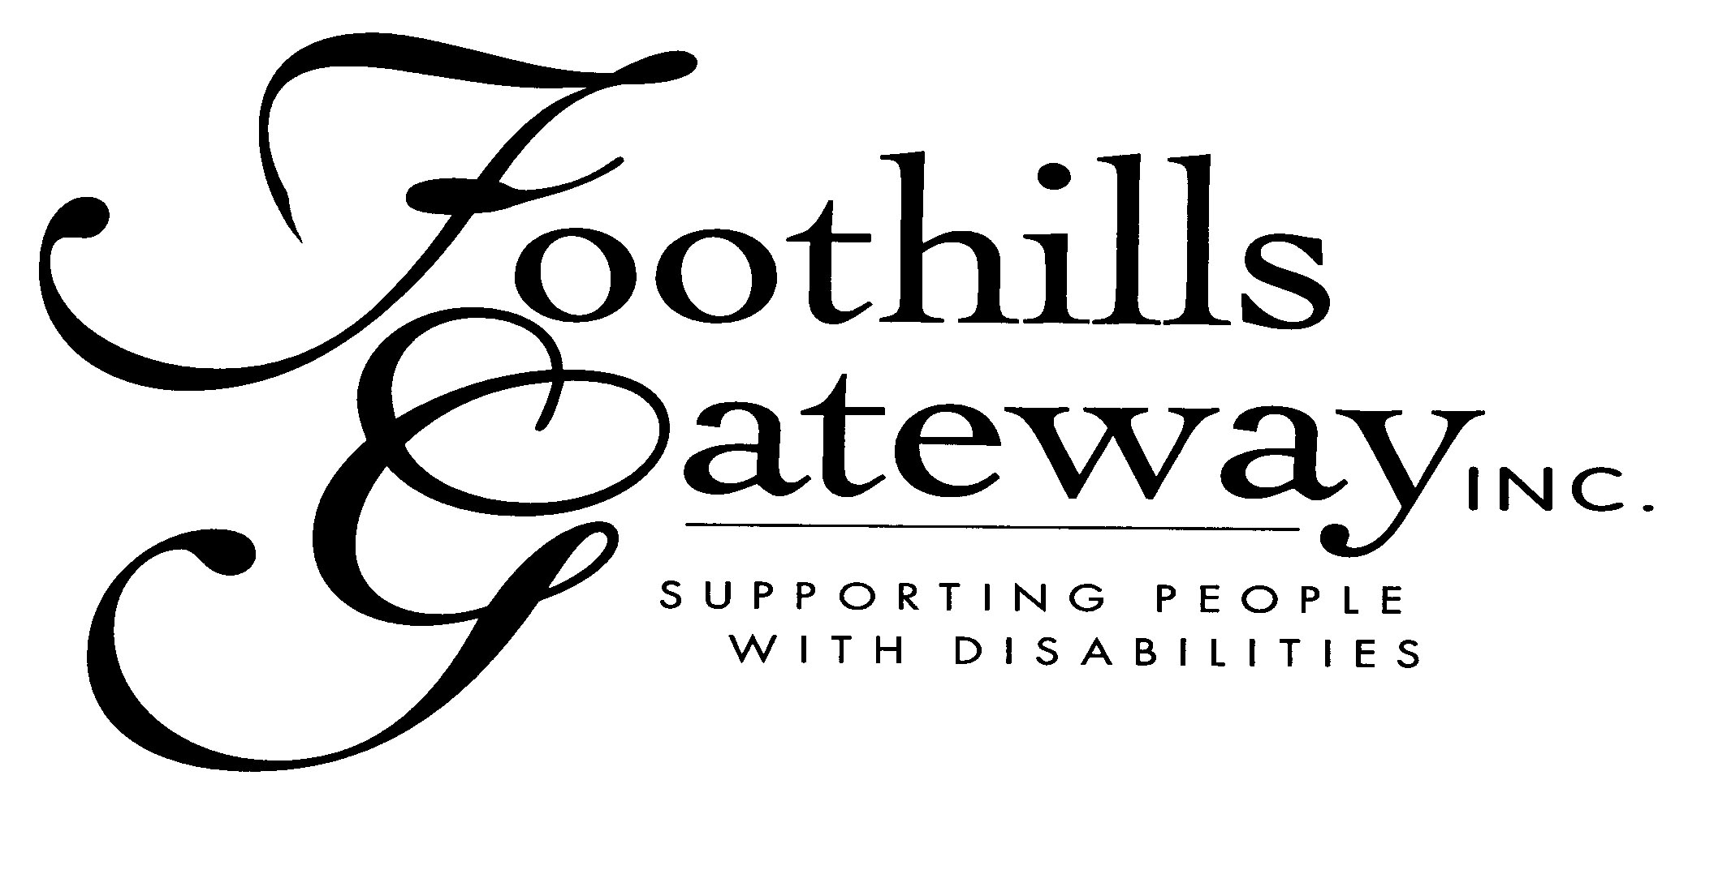

HEALTH SAVINGS ACCOUNT
DIRECT DEPOSIT Employee Authorization

______________________________
Contribution Amount (per pay period)

______________________________
Effective Start Date

______________________________________________________________________________
Full Name (Please Print)

Bank Name

Transit Routing Number

______________________________________________________________________________
Account Number

I hereby authorize Foothills Gateway, Inc. to deposit my Health Savings Account contribution each payday directly into the account named above. This authority will remain in force until I have given written notice that I am terminating it, or until my employer has notified me that this deposit service has been discontinued. I understand that I must give advance notice to allow reasonable time for my instructions to be executed (at least 5 business days prior to payroll). If an incorrect deposit should be made into my account, I authorize my bank and Foothills Gateway, Inc. to make the appropriate adjustments.

--OR--
 I elect not to contribute to a Health Savings Account until further notice. With this election, I understand I will not be eligible for any employer matching contribution.

______________________________________
Authorized Signature

_____________________
Date

